Open9x Manual

February 28, 2012
Deriving from Er9x manual, translated by T. Thibault
English translation August 8, 2012 by Z. Trojanek,
modified according to FW version r1195 September 2012

Table of Contents
Table of Contents 2
Disclaimer 4
Introduction 5
What is it? 5
How does It Works 6
What does this mean? 6
Open9X optional features (compile time options) 7
Transmitter Layout 8
Nomenclature 9
Inputs 9
Edit Buttons 10
Principles of control 10
Edit / Save 10
Navigating the screens 10
On the main screen 10
Select an item for entry 11
Changing values 11
Complete the process 11
Working with lists of items 11
Working with a selection from the set 12
Main screen 13
General View 13
Screens of statistics 14
General Settings 15
Radio Setup (1/6) 16
Trainer (2/6) 18
Version Info (3/6) 18
Diagnostics (4/6) 19
Analog Inputs (5/6) 19
Calibration (6/6) 20
Models Settings 21
Model Select (1/12) 22
Model Setup (2/12) 25
Helicopters Settings (3/12) 27
Phases of flight (4/12) 28
Expo/DR (5/12) 29
Mixer (6/12) 32
Main screen 32
Editing Mix row 33
Limits (7/12) 35
Curves (8/12) 37
Types of curves 37
Edit curves 37
Y-coordinate setting 37
X-coordinate setting 38
Selecting the type of curve 38
Custom switches (9/12) 39
Functions associated with the switches (10/12) 40
Telemetry (11/12) (if option FrSky is activated) 41
Analog inputs A1 and A2 : 41
Reception levels (RSSI) Tx and Rx : 41
The format of the serial protocol received (UsrData) : 41
The configuration of the gauge displayed on the screen Telemetry: 42
Templates (12/12) 43
Telemetry screens (if the option FrSky is chosen) 44
Gauges 44
Inputs A1 and A2 with Min and Max, as well as LiPo 44
Data from the altimeter, tachometer ... 44
GPS data 45
Examples 46
A throttle-cutting program 46
Instructions for building and programming 48
Building from source 48
Flashing (reprogramming of the radio) 48
Make Targets 49
MORE 50

Disclaimer
THIS SOFTWARE IS PROVIDED "AS IS" WITHOUT WARRANTY OF ANY
KIND, EXPRESS OR IMPLIED, INCLUDING BUT NOT LIMITED
WARRANTIES OF MERCHANTABILITY OR FITNESS FOR A
PURPOSE. YOU WEAR THE ENTIRE RISK OF
QUALITY AND PERFORMANCE OF THE PROGRAM. TAKING TO
YOU ASSUME THE COST OF ALL NECESSARY SERVICING, REPAIR OR
CORRECTION IN THE EVENT THAT THE PROGRAM PROVE DEFECTIVE.
For English translation:

The translation from French, paradoxically, I made because I can not read French. I have not found English version of open9x manual anywhere. Rough translation from Google Translator I corrected with the use of the English manual for ER9X and English manual torso from the open9x web site. Because I'm not too good in English, I originally not wanted to publish this translation. But then I realized that such unfortunates like myself are probably more. Publication even imperfect translation may help (as I hope). The translation I provided as is, without warranty of any kind whatever.

Zdenek

Introduction

What is it?
The IMAX/FLYSKY/TURNIGY/EURGLE 9x is a computerized radio from china.
The transmitter includes a black and white LCD 128 * 64 pixel, two stricks 2 axes, 3 potentiometers, 6 two position switches, one 3 position switch and trims.
The big thing about this transmitter is the price. At the time of writing radios may cost anywhere from € 120 for simple units up to more than € 500 for super blinged out bazillion channel super heavyweight monsters.
This one costs 60 €.
Where's the catch then? (you might ask) The catch is in the software (firmware - FW). The original is far from perfect, there are bugs, navigation erratic beep and worst I've ever heard. Not good.
A nice guy called THUS, realized that any radio is based on sticks, switches, trimmers and a simple micro controller goes everywhere. He had one of those ah-ha moments where insanity overrides common-sense and decided to completely rewrite the original software and replace it with his own.
Since then, several projects were born from the spirit Th9x in open source: er9x, gruvin9x, and open9x others I forget.
You can take a look at the code of Thus available here: http://code.google.com/p/th9x/. That
of Erazz available here: http://code.google.com/p/er9x/. And that of Bryan: http://code.google.com/p/gruvin9x/.
While you're there also RadioClone: ​​http://radioclone.org/

How does It Works
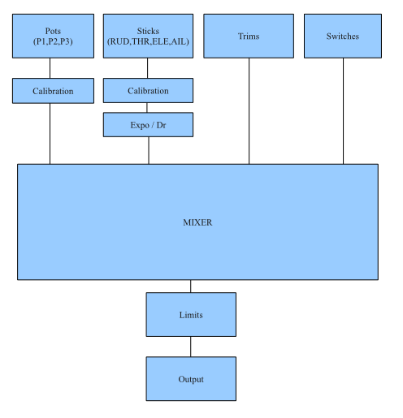
The figure is a simplified representation of signal processing in FW Open9X.

What does this mean?
The system has 4 main input devices:
- Main Sticks: Rud(der), Thr(ottle), Ele(vator), Ail(erons)
- Potentiometers
- Trims
- Switches
The analog inputs (sticks and pots) go through a calibration phase. The sticks can also go through Expo and DR filters before going to the mixer.
The mixer does it all. It directs each input to the desired output (CH1..CH16). It controls how the inputs are added. It also controls the timing of each function.
After the entries are processed by the mixer, they are redirected to their respective outputs, the limits are applied to avoid overshooting
Finally the channels are encoded and sent to the RF transmitter to take the path of air to your
model.
There are some kinds of additional inputs: PPM signal input (from Trainer connector), telemetry outputs (if the firmware is compiled for using FrSky or JETI - option FrSky or JETI are chosen) and user defined switches (CS1..CSC).
A more detailed description of inputs is in the paragraph Mixer in chapter Model Settings.

Open9X optional features (compile time options)
Open9X is able, among standard unmodified transmitter, work with transmitters that have been modified. It is provided as an adding various additional simple or more complex electronic modules which allow the base transmitter to provide additional functionality.
These functions are enabled by the inclusion of selected properties in the process of firmware translation and building.
On the contrary, if it is necessary to conserve memory (and processing time), it is possible to disable some features that are usually included.
There are ready-made firmware files for the most common combinations of options that can be easily downloaded from the Internet and then uploaded directly to the transmitter using Companion9X.
A brief overview of yet published options (which are displayed in Companion9X):
For hardware modifications and extensions:
- Audio - use sound module that allows the audio output with the optional speaker
- Haptic - the use of additional hardware for vibration signal
- FrSky - connection on the RF module with FrSky telemetry
- PXX - FrSky company PXX proprietary protocol support
- JETI - connection on the RF module with Jeti telemetry
- ArduPilot - receiving data from the module ArduPilot
- Voice - using voice synthesis module
- DSM2 - support for the use and adjustments for transmitter modules Spektrum DSM2
For the optional inclusion of other functions:
- Heli - include support for helicopters
- Nosplash - disable splash screen support
- NoFP - dropping flight modes
- NoCurves - dropping support for curves
- PPMC - setting PPM center in the limits
- PotScroll - use a potentiometer for setting in menu
- AutoSwitch - in model setup menus automatically set identification of switch by activating them
- NoGraphic - do not use graphical check-boxes
- NoBold – do not highlight active elements in bold
- Imperial - use "Imperial" units instead of metric
A current list of all valid options for translation FW (in English) can be found on the open9x project wiki at: http://code.google.com/p/open9x/wiki/CompilationOptions
The comment “(if the option xxxx is chosen)” is used in the description of the function in case of these optional functions.

Transmitter Layout

ELE SW

THR SW

RUD SW

P2

ID0/1/2

P3

AIL SW

GEA SW

TRN SW

Left Stick

Right Stick

[UP]

[DOWN]

[LEFT]

[RIGHT]

[EXIT]

[MENU]

P1

Nomenclature
(To understand each other)

Inputs
- Sticks (cross-drivers, levers):
- Rud (rudder)
- Ele (elevator)
- Thr (throttle)
- Ail (ailerons)
- Potentiometers
- P1 – potentiometer located at the top left, labeled “PIT TRIM” (and also labeled as ”[AUX. 2]” and “[POT. 7]”)
- P2 – potentiometer located on the left front, labeled “HOV PIT”
- P3 – potentiometer located on the right front, labeled “HOV. THR”
- Switches:
- THR - "Throttle cut" switch, not to be confused with the Throttle stick, the THR cut is located on the top of the radio on the left.
- RUD - rudder dual rate (labeled “RUD DR”)
- ELE - elevator dual rate (labeled “ELE DR”)
- ID0, ID1, ID2 - 3-position switch on the front, ID0 corresponds to the high position, ID1 the center position and the lowered position ID2. Labeled as “F MODE” (and also “[AUX 3]” and “[MIX]”).
- AIL - aileron dual rate (labeled “AIL DR”)
- GEA - landing gear (labeled “GEAR”)
- TRN - trainer switch. This switch is spring loaded.
- CS1 .. CS9, CSA .. CSC - Custom switches, you'll learn in time.
The symbol "!". When you see "!", must be read as a logical "not" (or "inverted"). The switch can be "normal" or "reversed". So when choosing the dual rate of elevator: "ELE" indicates normal operation, and "!ELE" indicates a reverse operation.
It should be stated that every function in this FW is assignable. There are no fixed switches, you can choose to use TRN to cut the engine and use the three position switch for dual rates.
The names are useful since they are labeled like that sticks on the Tx.

Edit Buttons
There are six edit buttons on the TX, in this manual are denoted with brackets like this: [MENU].
Some features require you to press the button for several seconds. It will be noted as a "long", eg: [MENU LONG]
You may have noticed that the buttons "+" and "-" are positioned so stupid.
I exchanged the positions of pieces of plastic with the "+" and "-" then "+" is right and "-" left, it's more intuitive. (Believe me I tried the original position.)
As you open your TX to use the FW (which voids the warranty) I strongly recommend the reverse, it's easy and you'll thank me.
To avoid confusion between those who have made the change and the other I'll refer to as
that [LEFT] (left) and [RIGHT] (right). I hope the left and right are still universal values, today we are no longer sure of anything ...

Principles of control
Open9X user interface is fairly consistent, a similar thing is done in a similar way.

Edit / Save
Generally any changed value is saved instantly. You can turn off the TX and on again it will be saved. The values ​​are stored internally on the EEPROM of microcontroller. However there is a slight delay sometimes so it's probably a good idea to wait a couple of seconds before turning off.
There is no function "undo", any change is for forever.
Generally, when a value is highlighted and you cannot move to left / right press [RIGHT] / [LEFT] will change this value. If you can move to left / right you will need to use [MENU] to edit the value. In edit mode the cursor is highlighted.
To exit the edit mode you can press [MENU] or [EXIT].

Navigating the screens
Generally, the [UP] / [DOWN] / [LEFT] / [RIGHT] cursor move along the corresponding direction.
Once in a menu you can navigate between screens using [LEFT] / [RIGHT] as long as the cursor is located in the upper right corner of the screen.
[MENU] button is used to select and start editing.
Press [MENU LONG] from the main screen takes you back to the last menu used.
[EXIT] is used usually to quit an activity. The [EXIT] to exit (you do not even doubt it?).
Pressing [EXIT] usually moves the cursor to the beginning of screen. Next pressing will do jump to the main screen.
[EXIT LONG] takes you back to the main screen immediately.

On the main screen
[RIGHT LONG] opens the settings of the model.
[LEFT LONG] invokes the general settings transmitter "RADIO SETUP".
[MENU LONG] will cause a return to the last used menu items.
Once in a menu you can navigate between screens using [LEFT] / [RIGHT] as long as the cursor is located in the upper right corner of the screen.

Select an item for entry
- using the four buttons to the left of the screen ([UP], [DN], [LEFT], [RIGHT]) place highlighting ("cursor") to the item you want to change
- press [MENU] to start the editing mode items.

Changing values
Generally, if the value is highlighted and you can not move the cursor left and right, you can use the [RIGHT] / [LEFT] to change the value.
If you can use the [RIGHT] / [LEFT] to move the cursor, you need to start editing the highlighted values ​​by pressing [MENU].
In edit mode, the cursor is highlighted.
To exit edit mode, you must press the [MENU] or [EXIT].

Complete the process
- All changes are immediately reflected in the settings and the radio is instantly governed by them. So for example, when setting the back-light, the display instantly illuminates and goes according to the current value.
- Value setting is ended by pressing the [EXIT] or [MENU]. No further confirmation as in the original FW is done, so you can not even go back to the original settings.

Working with lists of items
On the open9x menu are some items of list type.
For example the list of models on the first setup screen models, double deflection settings list, list of mixes.
In all these cases there are similar procedures for working with the list.
Inserting a list item:
The first line of each entry is inserted simply looking up by the entry cursor (using the [UP] and [DOWN]) and press [MENU].
Another row is inserted marking existing line and press [LEFT LONG] if it will be inserted before the line and [RIGHT LONG] after marked line.
Deleting list items:
- search line by cursor
- with [MENU] highlight a line
- [EXIT LONG] causes the deletion of the row
Editing list items:
- search line by cursor
- with [MENU] highlight a line
- [MENU LONG] causes the screen to edit the line
In the case of list of models the appropriate model is also selected as current .
Copy list items:
- search line by cursor
- with [MENU] highlight a line
- Move the cursor to the destination
- [MENU] causes copying the relevant line
Move list items:
- search line by cursor
- with [MENU] highlight a line
- [MENU] displays dashed box around the selected mřádku
- Move the cursor to the destination
- [MENU] causes the shift of the line
Editing texts:
On some pages, strings of charactres are entered (model name, the name of the flight phase).
- start editing with [MENU]
- [LEFT] and [RIGHT] to move the cursor left and right
- [UP] and [DOWN] changes the content under the cursor (capital letters, numbers and some punctuation).
- [LEFT LONG] - letter under the cursor will change from a large to small and vice versa
- [RIGHT LONG] - letter under the cursor will change from a large to small and vice versa, and move to the next character to the right
- end editing as usual ([MENU] or [EXIT])

Working with a selection from the set
In the open9x menu there are items used to select elements from some set.
These include the selection of switches to check it's state at power-up, selection of analog inputs for the central position beep indication (for checking the center of the pots), selection of flight phases in which the mix is ​​to be active, etc..
In the menu item is given a character string (eg 01234). Each character corresponds to the appropriate element of the set from which it is collected (eg. flight mode numbers). If the element are active, the corresponding characters are displayed in inverse.
It can be changed by moving the cursor using the [LEFT]/[RIGHT]. If the character is highlighted (flashing inverse display) corresponding element is selected for editing. Press [MENU] to change the state of the element from active to inactive and vice versa. Adjustments will end by leaving the item using the [UP] or [DOWN] or [EXIT].

Main screen

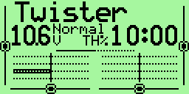
General View
The main view is split into two parts. The upper part consists of the following:
• The model name. Eg. Twister (a super glider, by the way)
• The name of the flight phase (when used – here “Normal”)
• The battery voltage of the transmitter (10.6V)
• The position of the trim
• The time counter (10:00) and its mode of operation (TH%).
The lower section has four screens accessed by [UP] / [DOWN].
• Bars values ​​- They show the state first 8 receiver outputs. For the state of second 8 outputs press [LEFT] or [RIGHT].
• Numerical values ​​- The values ​​of 8 first outputs of the receiver. For the values of second 8 outputs press [LEFT] or [RIGHT].
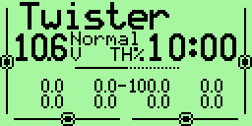
• Entry Values ​​- Position of sticks and switches. There are two screens for inputs: the physical inputs (sticks, pots, switches)
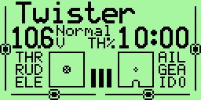

and the virtual inputs (virtual switches CS1 .. CSC, and virtual channels CH9 .. CH16 ..) To access the second screen, press [LEFT] or [RIGHT]
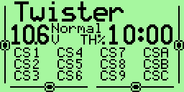
• The Timer 2 and its mode of operation: [EXIT] key resets the value of Timer 2
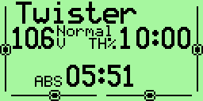
In the main view [EXIT LONG] resets the timers, counters and the telemetry data.

Screens of statistics
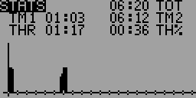
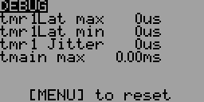
From the main screen press [UP LONG] will take you to the screens of statistics.
The first contains counters (total radio power on time, Timer1, Timer2, throttle stick counter to the absolute and percentage).
The second shows the internal counters TX, "tmain" represents the computation time. This time
increases with the complexity of the mix, it can become very large depending on the configuration of model.
You can reset this counter to 0 by pressing [MENU].

General Settings
From the main screen press [LONG LEFT] will bring up the menu general settings of the TX.
These settings are independent of the selected model and therefore "universal".
The menus are:
- Radio setup
Start alerts
- Trainer settings
- Version info
- Diagnostics
- Analog inputs
- Calibration

Radio Setup (1/6)
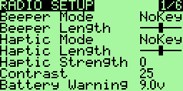
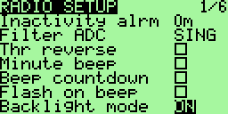
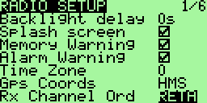
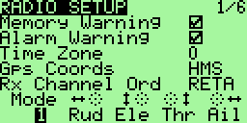
Use this screen to set the general parameters of TX:

- Beeper Mode: Setting the beeps
- Quiet. No beeps at all, no warning, nothing, if the children are asleep and you need to adjust your radio in the living room is the mode for you. Remember when same as the TX will not warn you if the battery runs dry. (Careful with the li-po!)
- Alarm. Only alarms (battery, radio off)
- NoKeys. Beeps but not on normal editing keys
- All. All beeps enabled!
- Beeper Length: Length of beeps (up to xShort xLong)
- Beeper Pitch: Adjustable Frequency of beeps (if the option AUDIO is chosen)
- Haptic Mode: Mode Setting the buzzer (if the option Haptic is chosen)
- Quiet. No vibration at all
- Alarms. Only alarms (battery, radio off)
- NoKeys. Everything But the editing keys
- All. All
- Haptic Length: Length of vibration
- Haptic Strength: Strength of the vibrator (0 to 5) (if the option Haptic is chosen)
- Contrast: LCD contrast, values ​​from 20 to 45. The higher the value the darker the screen.
- Battery warning: Battery voltage warning. When the connected battery's voltage drops below this voltage the Tx will beep. Though the Tx will continue to function normally it's really advisable to land as it is known that this FW was not able to fix the “zero voltage non functionality” problem of the original.
- Inactivity alarm: This will set up a warning that will beep if the Tx is left unattended for the specified amount of time. The default value is 10 minutes. To turn off the Inactivity timer – set the value to zero. Also, when running on USB power, the alarm is inactive. Values can be from 1 to 250 minutes. To reset the timer simply move one of the sticks.
- Filter ADC: Analog to Digital Conversion Filter
- SING: Converting simple, but with a faster resolution to 1024 steps.
- OSMP: Oversampling, uses more catches for 2048 steps, slightly
slower than SING.
- FILT: Filtered, available in case you have excessive noise on the conversion (servo
wriggling) This setting will filter the inputs to reduce noise. It will also
increase the latency time of 30 msec.
- Thr(ottle) reverse: This is for all you wacky people who fly with the throttle backwards (e.i. idle is far from you and full is close to you). Though I personally don't understand how you fly like that it's a nice feature. The reverse will also reverse the throttle warning on startup and some other throttle related functions.
- Minute beep: beep every minute when the meter is running ..
- Beep countdown: Beep at 30, 20, 10, 3, 2 and 1 second before the end of the counter.
- Flash on beep: Flash backlight at the beep.
- Backlight mode: Selecting the switch backlight switch on mode: OFF, Keys, Stks, Both, ON (backlight if installed).
- Backlight delay: Backlight duration after activation. Select from 0 to 500s.
- Splash screen: Displays the spash screen (if the option SPLASH is selected), by the way it can be skipped by pressing any button.
- Throttle warning: If ON will show a warning when throttle is not at idle when the Tx is turned on. The Tx will not output a signal until the alert is cleared. In latest versions of FW moved to model's individual selection.
- Switch warning: If ON will show a warning when the switches are not at the default position when the Tx is turned on. The Tx will not output a signal until the alert is cleared. In latest versions of FW moved to model's individual selection.
- Memory warning: If ON will show a warning when the available eeprom memory is less than 200 bytes when the Tx is turned on. The Tx will not output a signal until the alert is cleared.
- Alarm warning: The alarm of "last chance". This will give you a “heads up” if your beeper is silent. If on and the beeper is set to '0' (Quiet) you will receive a warning on startup. This has been added after a programing session left a user flying on silent. I find it really useful!
- Time zone: 1-12
- GPS coord: Select between NMEA and HMS formats of GPS coordinates
- Telemetry warning: The alarm that goes off when no data telemetry is received (if FrSky option is chosen)
- Rx channels ord: Allows you to choose how mixes will be applied to new models (assign channel numbers to sticks):
- RETA mean Rud = 1, Ele = 2, Thr= 3, Ail = 4.
- AETR means Ail= 1, Ele = 2, Thr = 3, Rud = 4.
- and so on ...
- Mode: Choice of stick layout between the TX MODE 1, MODE 2, and MODE3 MODE4.

Trainer (2/6)
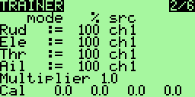
This menu allows the PPMin (trainer) inputs to be configured. It enables the RAW PPM inputs to be selected to replace the sticks for training purposes.
The student transmitter does not need to have the same model setup as the instructor. All the mixes on the instructors Tx will be applied to the student inputs. If, for example, you have expo on your sticks, this will be applied to the raw trainer inputs when they are selected.
- Mode: can take off as the value, + = (student value of the handle added to master) and : = (replaces the master's values ​​of the handle by the pupil's values)
- Percentage: percentage applied to the input PPM from student radio (useful when the student is a bit abrupt ...)
- Source to assign to the handle.
The multiplier is like wearing hello, it multiplies the input PPM. Useful for manufacturers of radio who can not properly encode the PPM :-P.
For calibration, highlight the "Cal" and press [MENU]. This will save the neutral point for all PPMIN channels (taking tuition).

Version Info (3/6)
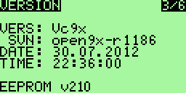
Screen displays the version of FW used.
VERS: Version Number
SVN: The SVN name of the FW
DATE: FW compilation date
TIME: Time of FW Compilation
Since that open9x is open source, I try to help all those who have problems, please
open tickets for bugs or new features on the project page:
http://code.google.com/p/open9x/issues/list
Your participation is what helps me make the best FW (and your donations of course).
Use the version number of this screen to report a bug, thank you.

Diagnostics (4/6)
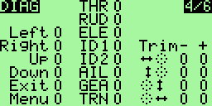
This menu will help you visualize the current state of the trims, keys and physical switches. Each Key/Switch/Trim is represented. When pressing a key or switch they are highlighted.

Analog Inputs (5/6)
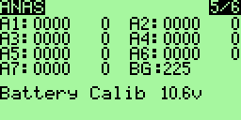
Here you can read the raw values ​​of Analog Inputs values in both hexadecimal and decimal format. Values ​​range from 0 to 0x3FF (0 .. 1023)
- A1-A4 are the sticks
- A5-A7 the potentiometers
- A8 is battery voltage.
- BG is band gap value
Also the battery voltage is measured and displayed.
On Analog Input Screen press [DOWN/UP] for highlighting the battery voltage
With [LEFT/RIGHT] you can adjust the displayed voltage value to match the value being measured with voltmeter directly connected to battery.

Calibration (6/6)
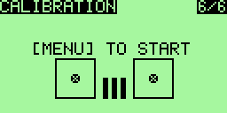
This screen allows you to calibrate the analog input A1 - A7
To calibrate this method follow:
1. Press [MENU]
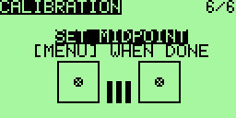
2. Put the controls in neutral
3. Press [MENU]
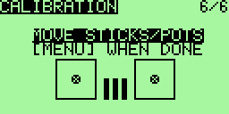
4. Move the handles and knobs from min to max.
5. Press [MENU] values ​​are saved..

Models Settings
From the main screen press [RIGHT LONG] takes you to the model select/settings menus. With this menu you can adjust the following settings specifically for each model (moving between menus by [RIGHT] and [LEFT] on the top menu line).
The menus are:
- Model Selection
- Model Setup
- Settings helicopters (if the option HELI is chosen)
- Phases of flight
- DR/Expo
- Mixer (This one is most important)
- Limitations
- Curves
- Custom switches
- Functions switches associating
- Telemetry (if the option FrSky is chosen)
- Templates (mixes preloaded - if the option TEMPLATES is chosen)

Model Select (1/12)
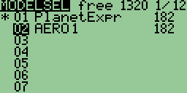
On this screen you can view, download, copy and move models among model memories. The memory management is dynamic.
The space used by each model is displayed on the right, the more complex (mixing, curves, options, limits ...) model settings will cost more space.
The star "*" on the left indicates which model is being active (loaded).
Using [UP] / [DOWN] move you among the models.
Pressing [MENU LONG] allows the loading of the selected model.
To duplicate a model:
- Choose the row to copy using the [UP] / [DOWN]
- Press the [MENU]. The line is highlighted.
- Then press [UP] or [DOWN] to duplicate it
- Choose the destination location and press [MENU] to confirm.

To move a model:
- Choose the row to copy using the [UP] / [DOWN]
- Double press the [MENU]. The line is highlighted, surrounded by a
dotted bar
- Then press [UP] or [DOWN] to move up or down to the destination location
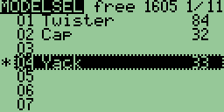
- Press [MENU] to confirm.
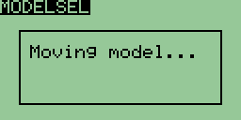
At any time during a copy operation or movement of a model it is possible to cancel
pressing the [EXIT].
To delete a model:
You can not delete the current model.
If you really want to do, you need to prior load another model.
- Choose the row to delete with the [UP] / [DOWN]
- Press the [MENU] to select

- Press the [EXIT LONG] to request the removal
- Confirm with [MENU] or cancel with the [EXIT]

Model Setup (2/12)
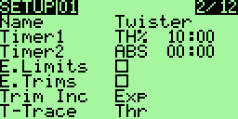
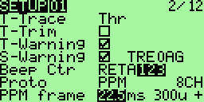
Many options are available here:
- Name: Not surprisingly this is the model name. To edit: and press down on it
[MENU].
After pressing [MENU] the first character will be highlighted.
To change the character use [UP] / [DOWN]. To move the cursor using [RIGHT] / [LEFT]. If you want to switch one letter to upper / lower case, use [RIGHT LONG] or [LEFT LONG].
Once finished, press [MENU] / [EXIT] to exit the editing
- Timer1: Setting the initial value of the counter.
Press [RIGHT] / [LEFT] to choose between seconds and minutes.
Press [MENU] and the cursor will blink. To edit using [UP] / [DOWN] / [RIGHT] /
[LEFT] and [MENU] / [EXIT] to exit.
A timer different from 0:00 will always count down, a timer equal to 0:00 is growing.
Trigger: Choose what triggers the timer (remember that by using [LEFT] you
have access to the same choice but with "! " to denote the reverse trip)
• OFF - Counter unused.
• ABS - Counter active all the time.
• THs / TH% / THT - Counter active function of engine (see below for its configuration). THs means start by moving throttle stick from minimal position and stop when return throttle stick to minimum. TH% means that the speed of the counter will be proportional to the level of gas. THt means that the counter will start at the same time as the engine, but it not stop (like Ths).
• Switches - You can specify a switch to activate the timer.
Momentary switches: A switch denoted with “m” (like TRNm) means “momentary” - pulse. That means that moving the switch once to the on position and back turns the timer on. Moving it on and off again turns the timer off. (difficult I know, take a sip from your coffee, relax a bit, take a break – it's not difficult once you try it out :) )
- Timer2: Same settings as for the Timer1
- E. Limits: Extended limits: allows deflections of 125%.
Before using this setting please verify (on servos, not only on display!) that it does not cause unwanted mixing between the channels!
- E. Trims: Extends the reach of trim from 1/8 of the race of the handle to 1/2. Note that if
trim position exceeds 1/8 (value + / -125), it will flash the message on the main screen to notify to a pilot that mechanical adjustment is necessary.
- Trim Inc.: Trim increments:
- Exp - Exponential: With this the trims are fine near the center and get progressively coarser farther out.
- ExFine (Extra fine) – 1 step per click.
- Fine - 2 steps per click.
- Medium (my favorite) - 4 steps per click.
- Coarse - 8 steps per click.
- T-Trace: Choice of method for detecting the engine speed:
- Thr – throttle channel
- P1 .. P3 – Potentiometers
- CH1 .. CH16 - Output channels
- T-Trim: This is a nifty feature for combustion engine fliers. When activated a couple of things happen. First off the center detent for the throttle trim is removed. Also the throttle's trim will now only affect the “low” side. That means you can use the trim for setting idle while full throttle remains unchanged.
- T-warning: If ON will show a warning when throttle is not at idle when the Tx is turned on. The Tx will not output a signal until the alert is cleared.
- S-warning: If ON will show a warning when the switches are not at the default position when the Tx is turned on. The Tx will not output a signal until the alert is cleared.
To set “default” position of switches set all switches to the appropriate positions and press [MENU LONG].
- Beep Ctr: Beep Center. Here you set center warnings. The character string RETA123 corresponds to: Rud, Ele, Thr, Ail, P1, P2, P3. When the letter corresponding to the analog channel is highlighted the system checks for center. When the input is at center a short beep will sound enabling you to hear when the input is centered. This is useful for checking the center of the pots without looking. (Use [RIGHT] / [LEFT] to select the channel and [MENU] to enable / disable.)
- Proto: protocol encoding:
- PPM – with PPM you can choose how many channels to encode. Anything from 4 to 16 channels. You can also change the pulse spacing. This is useful for systems which might experience jitter. On the whole it might be a good idea to leave it alone.
- Other protocols: DSM2 / PXX / PPM16
- Specific settings depending on the protocol chosen.

Helicopters Settings (3/12)

This screen is dedicated to setting a helicopter system ..
- Swash Type: defines the type of head (swash plate) of your helicopter:
- 120: "Standard" head to 120 °. The “pitch” servo is at the front / rear
- 120X: As 120 ° but rotated 90 ° so the “pitch” servo is on one side.
- 140: head to 140 ° - with “pitch” servo position forward / backward.
- 90: 90 ° Basically a simple 90° setup where you have a single servo operating the pitch and two operating the roll.
- Collective: Sets the source of the collective. The idea being that you can create a mix with all the required curves and switches and simply plug it in here to mix with the others.
- Swash Ring: Limitations of head movement (active only on channels Ail and Ele)
- ELE / AIL / COL Invert: Used to reverse the entry of these functions. Use these to make the controls move the correct way when setting up your heli.

Phases of flight (4/12)
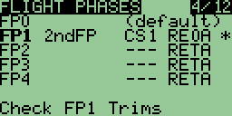
This screen is dedicated to the flight phases. 5 phases of flight are available. Each can be named and
the corresponding label is displayed on the main screen when the phase is activated.
To change the settings of a flight phase, choose it using the [UP] [DOWN] and
press [MENU].
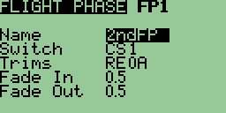
- Name: Lets you choose the label of the phase (6 characters)
Name of active Flight Phase is displayed right top from battery voltage in main screen
- Switch: Select the switch that will cause the activating this phase
- Trims: each trim (Rudder / Elevator / Throttle / Ailerons) may have their own value for each Flight Phase (options RETA) or be linked to the corresponding trim in another phase (options 01234) by selecting that phase number in place of RETA.
Example: RE0A means that trim for throttle stick is used from FP0 throttle stick (0). All other trims are autonomous.
- Fade In: allows a smooth transition when entering this phase. Transition time
from 0 to 15 seconds
- Fade Out: same as previous for output of this phase of flight
To return to the previous screen, press [EXIT]

Expo/DR (5/12)
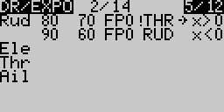
This screen allows you to assign an exponential, a curve or a weight to each stick (Rud/ Ele / Thr / Ail).
Furthermore, these settings can be enabled or not based on conditions on the flight phase, a switch or mode.
The curvature of the exponential characteristic is set to a value of -100 to +100. The weight
can be set from -100% to +100%.
For each set, there may be several lines of parameters. In this case, this is the first line for which all conditions are activated that is chosen and the others are ignored. There are maximum of 14 lines available for all 4 races.
To insert a line:
- When there is not already assigned to handle online, simply move with the keys
[UP] [DOWN] and press [MENU LONG]. Then you arrive at the setup screen
the new line.
- When there is already a dedicated line to the handle, there are two solutions: either get on the line just before with [UP] [DOWN], select it with [MENU] and press [RIGHT LONG], or get on the line right after with [UP] [DOWN], select it with [MENU] and press [LEFT LONG]
To delete a row:
Stand on the line to delete with [UP] [DOWN], select it with [MENU] and press [EXIT LONG]
To edit the values ​​in a row:
Stand on the line edit with [UP] [DOWN] and press [MENU LONG]. We arrives in the detailed menu below.
To duplicate a line:
- Stand on the line to copy, select it with [MENU]. The line is then reversed.
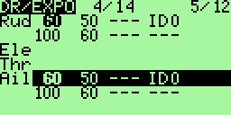
- Choose the destination using the [UP] [DOWN]
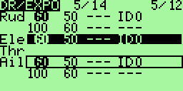
- Press [MENU] to run the duplication
To move a line:
- Stand on the line to move, select it by pressing twice the [MENU].
The line is then inverted and surrounded by a dotted line.
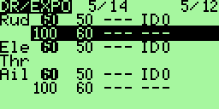
- Choose the destination using the [UP] [DOWN]
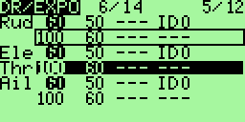
- Press [MENU] to complete the move.
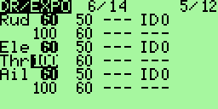
It can be interrupted at any time a copy operation or movement by pressing the [EXIT].

Sub-menu editing an expo:
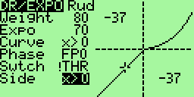
The screen consists of two parts:
- On the left are the parameters associated with the line.
- On the right is a curve as applied according to the present conditions. There are also the coordinates of the point associated with the current value of the handle.
Warning: this curve and coordinates depends not only on the current line editing but also other lines associated with the same handle!
For each line you can enter:
- Weight: the ratio for Dual Rates
- Expo: the value of expo
- Curve: A curve in addition to the expo:
- A predefined curve of x> 0, x <0, | x |, f> 0, f <0, | f |
- A custom curve c1 .. c8.
When a custom curve is selected, you can edit it by pressing the
[MENU]
- Phase: the phase for which the line will be active. You can enter "---" (all phases), FP0 .. PF4 (phases), and !FP0 .. !PF4 (!FPx means all phases except phase x)
- Switch: the switch that will activate the line of DR/EXPO
- Side: the input range for which the line will be active (for all applications where the input is negative, or when positive)

Mixer (6/12)
This part is the most important menu.
The function of the mixer is to take the inputs, perform some function on them and route them to the output channels. Since selection is totally free you have a very flexible system which is extremely powerful and very quick to boot.

Main screen
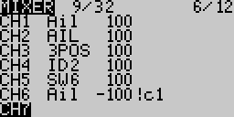
First row "19/32" = 19 used mixers from 32 available
Columns are:
- Channel number (CH1..CH16) or operand (+=/*=/:= means Add/Multiply/Replace Channel in upper rows)
- Source of mix (Bold mean that this row is active)
- Weight from -125% to 125%
- Curve applied on mix row
- Switch to activate mix row
- Delay (d), Slow (s) or both (*) applied on mix row
- Flight Phase number to activate mix row (empty or 0-4 phase).
Unlike the management of DR/EXPOS here when multiple lines are assigned to a channel, they are all applied (either the result replaces the calculation of the preceding line, or it is added, it is multiplied).
With Mixer rows we can do same Select/Copy/Move/Delete operations like in Models Setup screen
In this screen, the editing, deleting, copying and moving lines are exactly the same as for DR/EXPOS.
It is possible to edit the weights directly by accessing it with [UP]/[DOWN] and the amending with [LEFT]/[RIGHT].

Editing Mix row

On this screen you can change the mix individually.
The following options are available:
- Source: The source of the mix from the following choices:
- Stick or pot
- Trims – TRMA, TrmE, TrmT, TrmR – trim drivers can be used independently for setting input values. It is often used in conjunction with Thr trim control. i
- MAX: Used in conjunction with a switch: the value of the mix will be either 0 or that of "Weight"
- CYC1, CYC2, CYC3: The 3 outputs of the heli swash-plate mix. Once swash mixing is turned on (Heli menu – 3/10) these become active and hold the result of the swash mix. Generally CYC1 holds the fore/aft output and the other two do the rolling. On the 120X mode CYC1 is the odd one out.
- PPM1..PPM8: PPM input channels. These are fed by the ppm input or “trainer port”. You can use these to configure a buddy system or to simply extend your radio with more functions (like head tracking for you FPV guys).
- CH1 .. CH16: Those are the outputs of the other mixes, you can use to chain
mixes to produce very complex behavior.
- User-defined logical switches CS1 .. CS9, CSA .. CSC (see chapter Custom switches).
- Weight: This value multiplies the value from the input. It can be -125% to 125%.
- Differ (only in firmware before version r1393): The "Differential feature" is really easy to use:
- On the right aileron channel, you set +100 Weight and 60% as a differential value
- On the left aileron channel, you set -100 Weight and 60% as a differential value
It means than when your right aileron is 100% up, your left aileron will be 40% down. And vice-versa.
You have saved 2 Mixes. (There would have been another way to save mixes, using curves, but it's more complex...)
- Offset: This value is added to the value from the input. It can be -125% to 125%.
- Trim: If this option is enabled (ON), the trim value for the input channel (if any) is transferred through the mix. If OFF, the value of trim will be ignored. If an entry does not have a trim (not a stick) option ON is not accessible. A specific trim (Ail, Rud, Thr, Rud) can also be selected. So you can also trim inputs that do not have their own trims. Useful especially when the trim on the handle of throttle is not used, it can be assigned to something else ...
- Curve:
- x> 0: The value of the source will be taken into account if positive (otherwise 0)
- x <0: Same but for negative values.
- | X |: The value is passed as an absolute value.
- f> 0: If the source is a positive value is "+Weight", 0 otherwise.
- f <0: If the source is negative value will be "-Weight", 0 otherwise.
- | f |: The output will be "+Weight" or "-Weight" according to the sign of the source.
- c1 .. c8: custom curves, defined in the menu "CURVES 8/12" You can also press [MENU] to directly edit the curve.
- Diff (at this point in the menu since FW version r1393):
Number on the right is the value of differentiation in %.
If set Diff 0, there is no curve used.
Differentiation function deflections is used very easily:
  - The right aileron channel set weight +100 and 60% differentiation.
  - The left aileron channel set weight -100 and also 60% differentiation.
  - This means that if the right aileron is 100% up, the left aileron is down to 40%. And vice versa.
This will save two mixes. There is another way to save mixes - using curves - but it's a little more complicated.
- Switch: Here you can select the switch that will turn the mix on. If no switch
is selected then mix will be active all the time.
- Flight Phase: Here you can select the phase of flight in which will be active mixing. If no
phase is selected, it will be applied to all phases
- Warning: Here you can select an alarm when the mixing is active (only valid if a switch is selected), you can choose between 1, 2 or 3 BEEP, they will continually repeated.
- Multpx: This value defines how the mix will be added to the channel.
- Add: Its the default mode. With this value the mix is added to the previous values in the same channel.
- Multiply: Use this to multiply the previous values in the same channel.
- Replace: This value is used in conjunction with a switch. When the switch is off the value is ignored. When the switch is on the value discards the previous values and places it's own value in the channel.
- Delay Down / Up: Use this to delay use of this channel. Usually used with a switch. When the switch is turned “ON” or “OFF” the mixer will wait the specified number of seconds before changing the value.
- Slow Down / Up: Slow the rate of change in the channel. When not zero these will determine the maximum speed with which the value can change. The specified value is the number of seconds to go between -100% to 100%.

Limits (7/12)
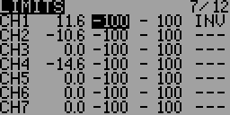
This is probably the second most important menu. The limits operate on the output channels (as you can see from the flow chart in the introduction). In the LIMITS menu you can set the center point (subtrim), limits (both left and right) and reverse the channel's output (INV – invert).
Each channel is represented by a channel of your receiver. The limits will be used on the channel indicated.
Columns:
- Offset : (or SubTrim): This sets the channel's center point.
The values of SubTrim can be -100 to 100 with increments of 0.1. This is done so to have excellent resolution when setting the center of each surface.
HINT: You can use your stick to set the center point as well. While the SubTrim is highlighted, hold the stick so that surface is centered. Press [MENU LONG] and the position will be recorded!
- Minimum channel Limit : and
- Maximum channel Limit : These two columns set channel endpoints. If the option "E.Limits" is ON then they can be in the range from +25% to -125% for the minimum and -25% to 125% for the maximum, otherwise the range is from +25% to -100% and -25% to +100%. Limits act as the "output gain" (indicates how many % servo throw is 100% of the output of the mixer) and at the same time as absolute limits. Servos can never get the order to sweep through the value set here.
Notice that there's an indication column that hints which side is active at the moment.
The value can be changed in the usual way - after after selecting the values ​​and press [MENU] using [UP], [DOWN], [LEFT] and [RIGHT].
- Between these two columns is located an indication column (with values: ->, -, ←). This column indicates whether the current value in the channel is zero or direction toward applicable limit.
- PPM center value (in microseconds). This is displayed since firmware version r1438.
- INV: reversion. This function allows you to reverse the output value for the channel. Use to match the servo signal direction to the method of servo installation in the model. The values ​​are '^' (reverse) and "=" (direct output). In previous versions (pre r1438) of FW the values are "INV" and "---". Changes can be made after highlighting (using [LEFT] and [RIGHT]), by pressing [MENU].
Trims2Offsets
You can find Trims2Offsets function on last line of limits screen. We use it to transfer all trims values to offsets after flight.
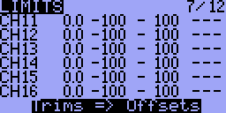
Pressing [LONG MENU] on line Trims => Offsets results in storing each Trim value to corresponding Channels Offsets. Trims are cleared.

Curves (8/12)
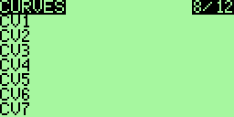
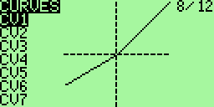

Types of curves
The curves are very useful to define the movement of the servo when you move your handle. In open9x there are 8 curves available. Any of the curves can be 3-point, 5-point, 9-point and 17-point.
A 3pt curve is a curve you can edit at position -100%, 0%, 100%.
A 5pt curve is a curve you can edit at position -100%, -50%, 0%, 50%, 100%.
A 9pt curve is a curve you can edit at position -100%, -75%, -50%, -25%, 0%, 25%, 50%, 75%, 100%.
A 17pt curve is a curve you can edit at position -100%, -88%, -75%, -63%, -50%, -38%, -25%, -13%, 0%, 12%, 25%, 37%, 50%, 62%, 75%, 87%, 100%.
There is a type of curve with the possibility that the value of the x coordinate of each point can be changed. This type of curve has a name with an apostrophe attached at the end.
All curves share a common memory area. This means that it may not be possible to use all eight such curves with 19 points each.

Edit curves
When you enter this menu you should see a long list of curves. Go down to the curve you wish to modify and then press [MENU] or [RIGHT]. This will take you to the curve edit screen. Depending on whether you choose a curve has 3, 5, 9 or 17 points you will see 3-17 points editable.

Y-coordinate setting
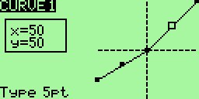
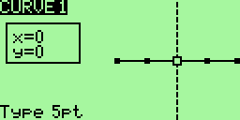
You move from point to point with [LEFT] / [RIGHT]. Change the value with [UP] / [DOWN]. When editing is finished, press double [EXIT] to return to the previous menu.

X-coordinate setting
There is a type of curve with the possibility that the value of the x coordinate of each point can be changed. This type of curve has a name with an apostrophe attached at the end.
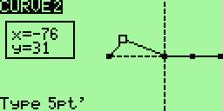
If you edit a curve, allowing changes to the x-coordinate of each point, you can also move each point in the x-coordinate.
Select a point and press [MENU]. Selected point blinks. Then you can move the point in the direction of the x (and y) coordinate by pressing the [LEFT] / [RIGHT] (and [UP] / [DOWN]). When editing is finished, press [MENU] or [EXIT]. You can then go to the next point.

Selecting the type of curve
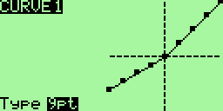
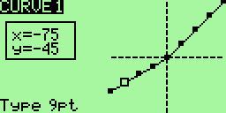
The first press of [EXIT] moves the cursor to the type of curve selection field. Then you can press the [LEFT] / [RIGHT] to change the type of the curve. Press [MENU] for return to curve editing, [EXIT] to close curve editing and return to curves selection (main) screen.

Custom switches (9/12)
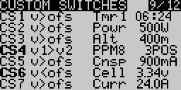
Custom switches are not really switches at all but rather a set of logical conditions that can be used as switches.
You might have noticed that beyond the physical switches there are 12 switches called CS1..CS9 and CSA..CSC. These correspond to the list you see in this screen. Once the condition defined for the switch is met it's value will be “ON”
- First we define the condition. This can be v>offset, v<offset, |v|>offset and |v|<offset, or it can be a logical condition: AND, OR, XOR, or it can be an comparation between 2 sources.
- If you have chosen a conventional operation must specify a source and a value:
  - The source may be a handle, a pot, a PPM input, an output channel (CHxx), a Timer
(TMR1, TMR2) or an input telemetry.
  - An offset is a value that will serve as a point of comparison.
- If you chose a logical operation the result will be that the condition applied to two selected switches.
For example: OR ID1 ID2 will be “ON” if either ID1 or ID2 is on.
- If you selected a comparison ("==", ">", "<" etc. ...) you must select two sources to be compared.
For example: Switch on only if CH1 is less than Rud → v1<v2 CH1 Rud
Example:
Imagine that you have a glow plug igniter to activate when the throttle is <20%:
- Highlight CS1
- Select THR as the source.
- Choose an offset of -80 (remember from -100 to 100 is 20% above the slowing -80).
- Select the condition v <ofs.
Now you need a mixer to use switch CS1, go to the menu mix, select CH8 for your glow plug. Take this path "MAX" in source and CS1 as "Switch". And now whenever the throttle goes below 10%, CH8 will go to 100%. Cool, huh?

Functions associated with the switches (10/12)
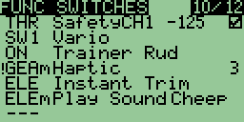
This screen allows you to associate one or more functions for one switch.
For example you may need a security switch on the throttle channel to be able to adjust your electric model without fear of starting the propeller due to an error of programming (or an unfortunate attachment of the throttle stick).
To do this, you will associate a switch (eg. THR) with the "Security Ch" on the throttle channel with a value of throttle power off. (This function adds just one extra level of security to reduce our passion risks).
You may set actions for all type of switches:
- Physical switches (THR, AIL, ID0, ....),
- Logical switches (CS1-CSC, always ON),
- Momentary switches (THRm, CS1m, ONm, ...) they are switched only once and then their condition return back. Usually for playing sound, for landing gear, instant trim ....
- and all above Negative switches (!THR, !CS1, !RUDm, ...)
Functions:
- Safety channels CH1 .. CH16 with adjustable output value from -100 to 100 and ON/OFF check box to increase safety while setting up values.
- Trainer
- Trainer for a single channel (Rud / Ele / Thr / Ail)
- Instant Trim to trim your model instantly from the stick positions.
Note: Trims are not transferred for Thr stick.
New trim values are active for each Flight Phase where same trims are used.
If +-25% trim is not enough, activate extended trims (+-100%) in model setup screen.
- Play Sound: play a sound
- Vario to enable vario audio warnings (see section Configuring a Vario).
- Reset timer1, timer2 or telemetry values
- Haptic run vibration (needs Haptic Mod and haptic firmware option)

Telemetry (11/12) (if option FrSky is activated)
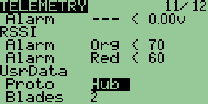
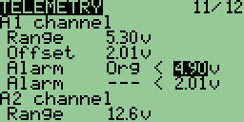
In this menu are all the settings for displaying telemetry FrSky, and the configuration associated alarms.

Analog inputs A1 and A2 :
For each entry, you can set the following:
- Range: the received range of values, for a voltage for example, from 0 to 204.0 v!
- Offset: a shift, allowing a finer calibration
- Two alarms corresponding to alarms module FrSky:
- Alarm level (---, yellow, orange, red)
- Sense of alarm from the threshold (<or>)
- Threshold value
When a value is modified, it is immediately sent to the module FrSky.

Reception levels (RSSI) Tx and Rx :
Same principle, it is possible to set two alarms to the reception level:
- The alarm level (---, yellow, orange, red)
- The threshold value
When a value is modified, it is immediately sent to the module FrSky.

The format of the serial protocol received (UsrData) :
- Proto: Protocol user. This is the serial protocol used by the telemetry receiver. The
options are: None (not used), the Hub FrSky or module Winged Shadow How High (he
gives only the altitude, but it is more accurate)
- Blades: The number of propeller blades for displaying the tachometer

The configuration of the gauge displayed on the screen Telemetry:

It can display up to 4 gauges on the screen telemetry. Here are the parameters:
- Source: what will be displayed
- Min: the minimum value displayed
- Max: the max value displayed
Milestones displayed on the screen automatically from telemetry information from alarms FrSky, switches or virtual. So if you set a virtual switch when the altitude is 400 m, you will see a mark at 400m.

Templates (12/12)
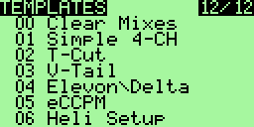
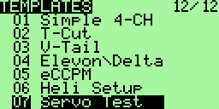
The templates are here to help with settings for a model. Entering this menu you will see the list of available templates. To choose a template, scroll down to it and press [MEU LONG]. This will add the template to the existing mix of the current model.
At the end of the list you will see the option CLEAR MIXES [MENU]. Press [MENU LONG] on this value eliminates all mixing of the current model.
The templates available:
- Simple 4-CH: Classic 4 channel aircraft .
- T-Cut: This adds a throttle cut mix on your throttle channel.
- V-Tail: Tail in V.
- Elevon \ Delta: Lift up or mixing for delta wing.
- eCCPM: A generic mixing for electric collective pitch.
- Heli Setup: Use upstream of eCCPM: resets the mixer and curves for eCCPM use.
- Servo Test: Set up a test signal on the servo CH15. To test a servo track with a mix CH15 and your servos will move slowly from -100 to 100.

Telemetry screens (if the option FrSky is chosen)
These screens are accessed by pressing [DOWN LONG] from the main menu. In depending on what you have configured, views may differ. You move from one screen to the other using the [UP] [DOWN]. The [MENU] button resets the telemetry data. Finally [EXIT] returns to the main menu.

Gauges

Inputs A1 and A2 with Min and Max, as well as LiPo

Data from the altimeter, tachometer ...

GPS data
Here shows the latitude, longitude and altitude of the model, and the distance of the model driver. By resetting the telemetry data, the first GPS position received becomes the known position of the driver for future calculations.

Examples

A throttle-cutting program
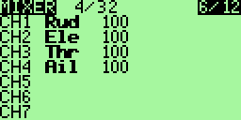
Although you can do with a template via the instructions here mixes. Start with
a conventional 4-channel mixer. Get off on the throttle channel like this
Press [MENU] to select the line and [RIGHT LONG] to add a line after the current and enter the menu "Edit Mix".
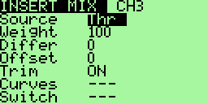
Change the source by "MAX" and weight "weight" by -100.
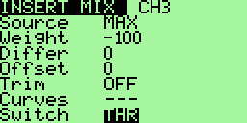
Remember to select a switch.
Continue down until you reach "Multpx". Change the default "Replace"
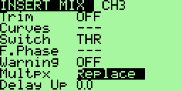

Now press [EXIT]
You should get the following screen:
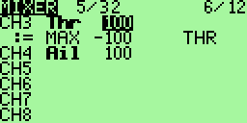
This indicates that you have two mixes on the way CH3.
The first uses the value of the throttle stick. The second depends on the state of switch THR. When THR is ​​OFF then mix is ignored and CH3 has the value of the handle. If THR is ON, the value of CH3 is -100%.

Instructions for building and programming
You'll want to modify the code to your own needs, it is very easy if you know the C language.
First to program the microcontroller following the instructions: Flashing the 9x by Jon Lowe.

Building from source
Use SVN to get sources:
svn checkout http://open9x.googlecode.com/svn/trunk/ open9x
Put yourself in the src
To compile the standard version: make
For version FrSky enter: make EXT=FRSKY
(See this page: http://code.google.com/p/open9x/wiki/CompilationOptions to list
options)

Flashing (reprogramming of the radio)
(In Linux you have to be admin for that USB port on)
To write the FW: make wflash AVRDUDE_PROGRAMMER=usbasp
Write to EEPROM: make weeprom AVRDUDE_PROGRAMMER=usbasp
To read the FW: make rflash AVRDUDE_PROGRAMMER=usbasp TARGET=backupflash
For the EEPROM read: make reeprom AVRDUDE_PROGRAMMER=usbasp TARGET=backupeeprom
Remember to replace "usbasp" by the name of "your programmer.
For a list of supported type programmer: avrdude-c?

Make Targets
- make all (default): Compile sources
- make clean: Deletes the compiled files and folders.
- make wflash: Write flash (program) memory.
- make rflash: Reads the FW.
- make weeprom: Program the eeprom.
- make reeprom: Reads the EEPROM.
- make coff: Convert ELF to AVR COFF.
- make extcoff: Convert ELF to AVR Extended COFF.
- make debug: Starts the debugger.
- make simu: Starts the simulator (which is used for including screenshots)

MORE
I hope you enjoy the open9x FW!
This is an OpenSource project, which means I do not ask for money in return, and you are free to view, download, edit and re-distribute the code under GNU v2 license.
If you have any questions, improvements, or to submit compliments, I would be happy to to read either on the official project page: http://code.google.com/p/open9x/
Either on the forums 9xgroups: http://9xforums.com/forum/viewforum.php?f=45
Specifically for bugs / enhancements: http://code.google.com/p/open9x/issues/list
open9x and companion9x are free to use under the GNU License v2.0. I spent (and continue) much time to make this software as good as possible. If you feel that you me a favor you can do this € 5 donation will be greatly appreciated and you will be added to the list of contributors in the code. (Optional of course)

Advertise for this cheap radio to your friends, I bet he will look at you with big eyes exclaiming that you'd better go buy a "real" radio. It does not matter, you will have more money for "real" aircraft!

